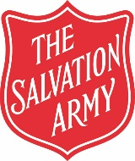

Scarborough
Salvation Army
Church and Community Centre

Major Stephen & Captain Angela Noble
Corps Officers

Tel: 01723 378603
Mob:
Email: Angela.Noble@salvationarmy.org.uk
Stephen.Noble@salvationarmy.org.uk

Christmas Day Meal for the Elderly & Homeless 2020
Christmas Dinner application form for those
who will be on their own for Christmas

This form must be completed and returned to The Salvation Army
no later than 10am Friday 18th December 2020.

Please note that we will be delivering this to your home on
Christmas Eve between 10:00 am and 12:00 pm

Name
(Mr/Mrs/Miss)__________________________________________________________________________

Address:______________________________________________________________________________

________________________________________________________________ Postcode ______________

Telephone Number_______________________________________

Please note any allergies that we need to be aware of below

